React Notes :

REACT :

Hooks :

UseState : to update state

const[time,setTime]=useState(2.00)

UseEffect : takes a callback func and a dependency array

every time the components in the dependency array change , the function specified is called

useEffect({},[func,components])

useCallback..(same syntax as useEffect)

usually for writing functions

useId()

gives unique ids

const ids=useId()

useParams()

if u enter smthg after slash in browser it will be rendered

const uid=useParams()

<h1> {uid}</>

Router :

Link tag : used instead of <a> tag so that the page does not load unlike in a tag

Navlink is also used

Intro to a Layout file :

We pass heard footer and a <outline> btw them

Outline is all that comes bw the 2 components

In main.jsx we show use of nesting by outine as follows :

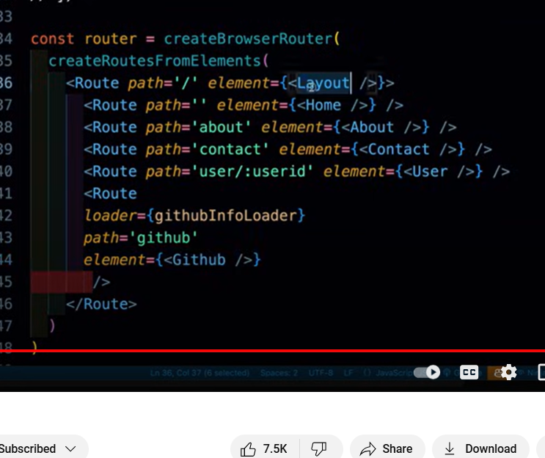

Render <RouterProvider router={router}>

Dynamic elem can be rendered using useParams like in user

API calling using loader in router can be done as follows : 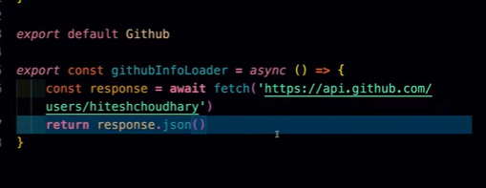

CONTEXT API :

Create a folder : use Createcontext() method

Export the file -> context acts as a wrapper for all elem inside it